Chapter 1

Introduction To Selenium

- Introduction

In this chapter , we will learn how to install Python, binding Selenium libraries with Python, how to install and configure PyCharm IDE. At the end of this tutorial, you will be able to code and execute a Selenium test script using Python Programming language in different web browsers.

- Why Automation Testing

Now, if you are a software developer, you might have heard of Agile workflows. With the need to perform in-sprint testing for every new feature that is added, it is a popular tool. For applications that are small, it is okay to perform manual testing. However, for applications with complex requirements and tons of dependencies, it’s impossible to perform in-sprint testing continuously. Moreover, most of these tests are repeated, and it’s not wise to perform the same testing again and again, although it’s necessary. This problem can be easily solved by automating testing.

3. introduction to selenium

Selenium is an open-source automation testing tool that supports several scripting languages like Python, C#, Java, Perl, Ruby, JavaScript, etc., depending on the application to be tested. One can choose the script accordingly.
Selenium allows you to define tests and automatically detect the results of these tests on a pre-decided browser.

Pre-request for selenium;- a basic understanding of front-end concepts like DOM and familiarity with Python is expected.

4. Why selenium with python

Python is one of the most popular and on-demand programming languages right now. The reason is obvious; it offers plenty of benefits to its users and is considered as an all-rounder. You can create websites using Python by leveraging tools such as Flask, Django, and so on. It is also possible to perform web automation using Selenium. And you can use Python for Data Science and Machine Learning, etc. Its simple syntax and the tons of libraries and packages it provides, make it a favorite among programmers.

Python is incredibly easy to learn. It's open-source, free to use, high-level, interpreted, and has one of the largest developer communities worldwide, who are ready to solve any problem you have.

One of the most widely used test automation tools in Python is Selenium. It’s open-source and free to use. Selenium with Python is used to carry out automated test cases for browsers or web applications. You can easily use it to simulate tests such as tapping on a button, entering content to the structures, skimming the entire site, etc.

- Selenium Arichitecter

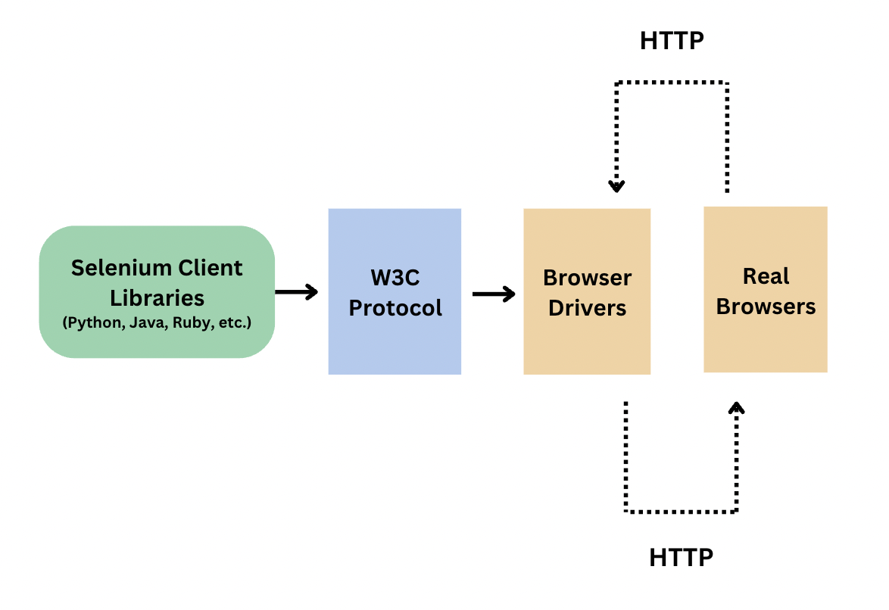
- Selenium test script - Selenium test script is the test code written in any of the mentioned programming languages that are interpreted by the driver
- W3C Protocol - there is a direct information exchange between the client and server, without the need for the JSON Wire Protocol.
- Browser drivers - Selenium uses drivers, specific to each browser to establish a secure connection with the browser
- Browsers - Selenium WebDriver supports multiple web browsers to test and run applications on.

- Selenium Webdirver

Selenium WebDriver is a web framework that permits you to execute cross-browser tests. This tool is used for automating web-based application testing to verify that it performs expectedly.

WebDriver is designed as a simple and more concise programming interface.
WebDriver is a compact object-oriented API.
It drives the browser effectively.

Selenium WebDriver allows you to choose a programming language to create test scripts. As discussed earlier, it is an advancement over Selenium RC to overcome a few limitations.

To understand why WebDriver was introduced, let's look at the shortcomings of Selenium RC.

Selenium Remote Control (RC):- is a test tool that allows you to write automated web application UI tests in any programming language against any HTTP website using any mainstream JavaScript-enabled browser.
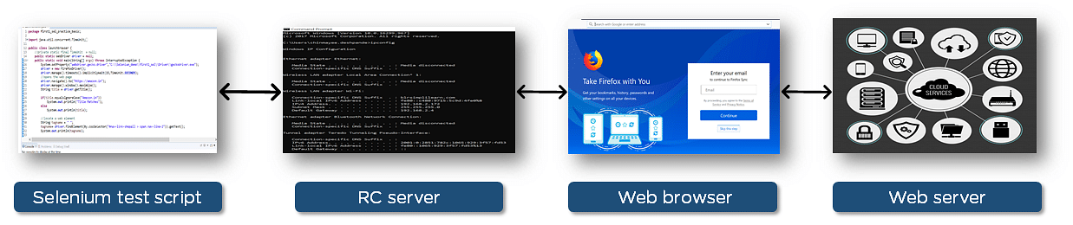

Selenium RC Server receives Selenium commands from your test program, interprets them, and reports the results back to the program. The Web browser is injected with Selenium core, which interprets and executes the Selenese commands used in the test script. The web browser now interacts with the web server accordingly. This setup, however, complicates the architecture and takes additional time for execution.

Let's see how Selenium WebDriver helped overcome these drawbacks. The WebDriver does not use an additional server, instead of making direct calls to the browser using each browser's native support for automation.
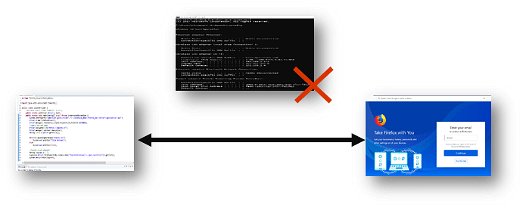

Selenium WebDriver is not capable of handling window components, but this drawback can be overcome by using tools like Sikuli, Auto IT, etc

7. Setup envaroment for selenium

- Install Python

In this section, we will see how to install Python on windows machin. But before we install, we should first check if Python is installed on our system or not.
Let’s open our terminal and run the following code.

python --version

NB: on windows , the terminal(Command Prompt) can be opend by clicking on the windows key then by typing Command Prompt and pressing Enter

- If the output shows a Python version, then Python has already been installed in your system.
- If the version is older than the latest, then we will have to upgrade it. for upgred and installtion the same step.
- However, if Python hasn’t been installed yet, then the warning message below will appear instructing us to run “python” without any argument in order to install Python via Microsoft Store.

This is the steps to install and upgrade python.

- Visit the Python Releases for Windows section on Python’s official website to find the desired version of Python.

- Click the Download Python button to download the installation file for the version you want.

- Run the downloaded installer. If you’re upgrading from an existing Python 3.x installation, the installer will allow you to install the newer version alongside the older one.

- During the installation process, ensure that the “Add Python to PATH” option is checked, so the new version is available in your system’s PATH.

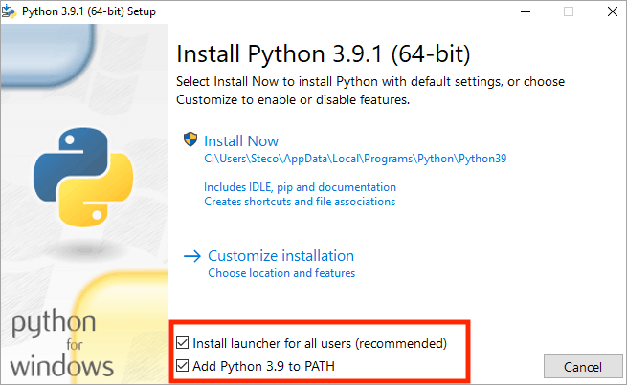

- Finally, open a command prompt and type the blow command to verify that Python has been install or updated successfully.

python --version

- Download and install PyCharm IDE.

NB: downolad and install pyCharm is three step process.

Step 1. Download the PyCharm

Download the PyCharm installer for Windows from its official website, jetbrains.com. We recommend not to download from other sources.
Follow the steps below to download PyCharm on Windows:
1. Go to the JetBrains website.
2. Under the Community section, click on the Download button for the Windows package.
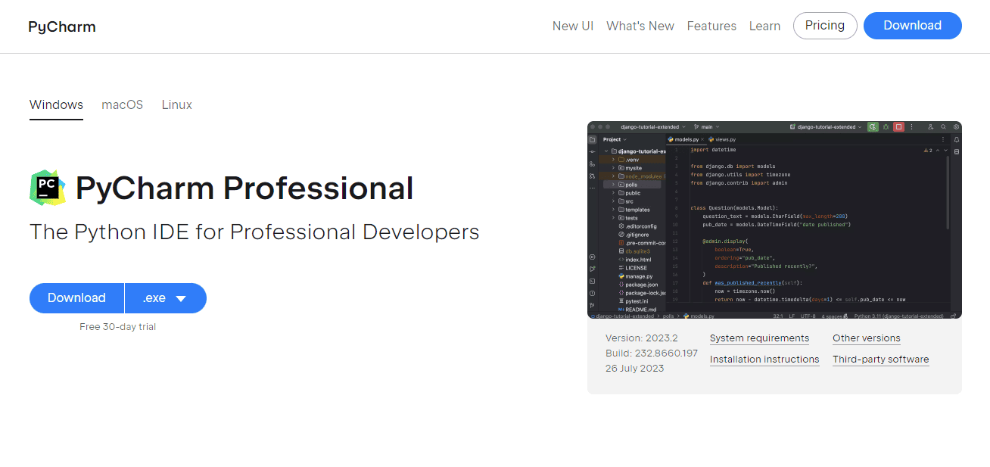
3. An exe file will be downloaded to your system. Note the location where the exe file is saved.

Step 2. Install PyCharm

Once the download is complete, follow the steps below to install PyCharm on your Windows machine:

1.Navigate to the exe file location and double-click on it to start the installation.
2. You will be presented with a wizard to guide you through the installation process. Click Next to continue.
3. Accept the User Agreement and click Next.
4. Select the installation location on your system and click Next. It is recommended to use the default location.
5. Choose the Start menu folder name for shortcuts and click Next.
6. Select the additional tasks like creating a desktop shortcut and associating Python files with PyCharm. Click Next.
7. Verify all the settings and click Install to begin the installation process.
8. After installation, uncheck the Run PyCharm option if you want to configure it later. Click Finish.
The PyCharm executable will be added to the Start Menu and desktop (if selected).

Step 3. Reboot & Launch PyCharm

We recommend rebooting the machine to save the PATH variable settings.
Follow the steps below to launch PyCharm after installing it:
1. Open the Start Menu and click on the PyCharm icon under JetBrains to launch it. Alternatively, double-click the desktop shortcut if you have created one.
2. When launching for the first time, a welcome screen will appear, which will guide you through some configuration settings.
3. Click Next and choose your UI theme. You can choose from Dracula (dark) or IntelliJ (light).
4. Next, choose whether you want to customize the IDE, install plugins, etc. Select Skip Remaining and Set Defaults to quickly jump to the IDE window.
5. PyCharm will index the files on the first launch, which helps with faster code assistance later. You will see a progress bar indicating the indexing status.
6. After indexing is complete, you will see the PyCharm IDE window with a tip of the day.

Your PyCharm is now ready to use!

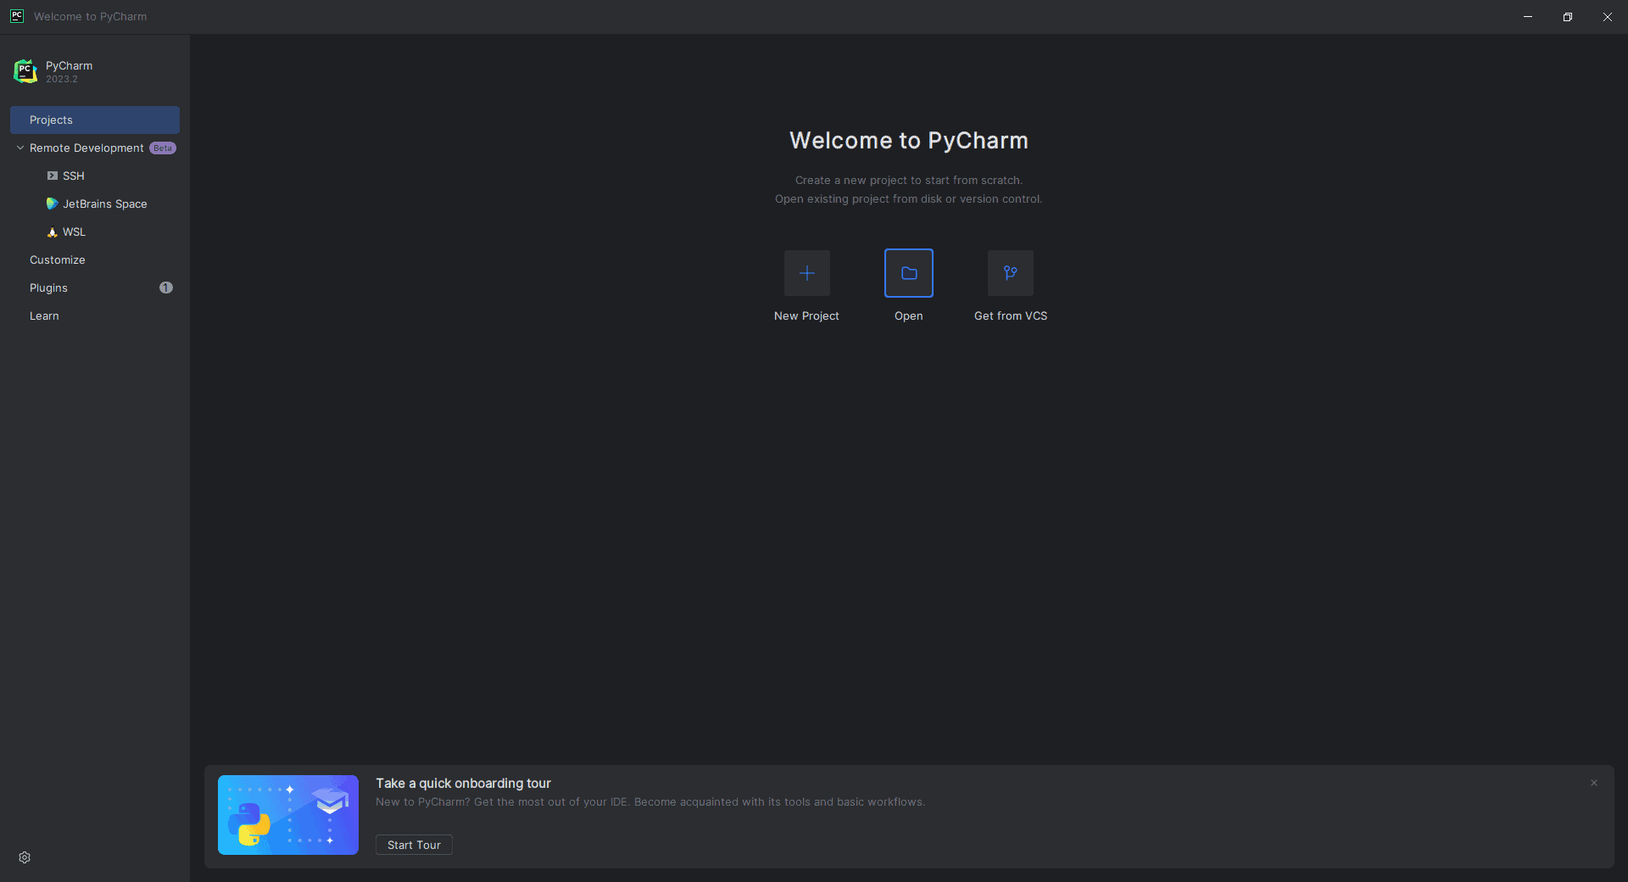
- Install selenium as package

To install the letest version of selenium run the blow command on terminal.

pip install selenium

- Downoad and setup webdirver

The next step is to install the specific web drivers for the browser on which
you want to run the test cases on. Thi s are list of driver. Copy the link and download zip file for all driver.

Chrome: | https://sites.google.com/a/chromium.org/chromedriver/downloads
Edge: | https://developer.microsoft.com/en-us/microsoft-edge/tools/webdriver/
Firefox: | https://github.com/mozilla/geckodriver/releases
Safari: | https://webkit.org/blog/6900/webdriver-support-in-safari-10/

Then extract zip file and copy the .exe file to put in python script folder.
NB: the blow path is location for python script folder.
C:\Users\efrem\AppData\Local\Programs\Python\Python311\Scripts
Note: You have to change the red colore marked part with your account name.

8. First Test Code with selenium

To write first code with python by using pyCharm IDE this is the steps.

Step 1. open pycham IDE.
Step 2. create new python project name as “Selenium_Test_Code”.
Step 3. create new directory name as “Chapter 1”
Step 4. create new python file under Chapter 1 directory name as“first_test_code.py”.
Step 5. open new created python file and type the blow code.

- First, import the WebDriver and Keys classes from Selenium.

from selenium import webdriver
from selenium.webdriver.common.keys import Keys

The WebDriver class will connect you to a browser’s instance, which we will shortly cover.
The Keys class lets you emulate the stroke of keyboard keys, including special keys like “Shift” and “Return”.

- Next, create an instance of Chrome with the path of the driver you downloaded through the websites of the respective browser. This example assumes the driver is in the same directory as the Python script you will execute.

my_driver = webdriver.Chrome()

If you are testing on your local machine, this opens an instance of Chrome locally. This command lets you perform tests on it until you use the .close() method to end the connection to the browser.

- Next, use the .get() method of the driver it accepts URL of website to load a website. The .get() method starts loading a website and waits for it to render completely before moving on to the next step.

NB: for this example we are going to test this website.”

URL = “https://opensource-demo.orangehrmlive.com/web/index.php/auth/login”
my_driver.get(URL)

- Once the page loads successfully, now you can select any html element to test. By using .find.element(By.ID,” id_of_element_selected_element”) or .find.element(By.NAME,” name_of_element_selected_element”)

NB: For this exapmle we are going to test login page of orangehrm website
URL = “https://opensource-demo.orangehrmlive.com/web/index.php/auth/login”
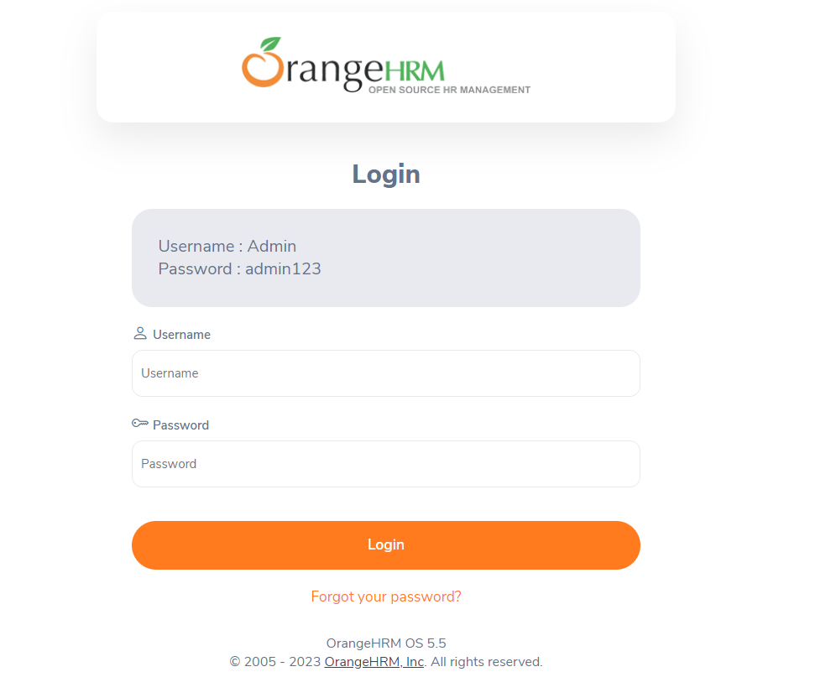
username_filed = my_driver.find.element(By.ID,””)
password_filed = my_driver.find.element(By.ID,””
login_button = my_driver.find.element(By.ID,””)

- Once the DOM element is selected, now it is time to intaract with element to see change. Intraction with element depend on the type of element. This is the two method we will use to intract with selected element.

.send_keys() // to type in filed
.Click() // to click the button.

username_filed.send_keys(“Admin”)
password_filed.send_keys(“admin123”)
login_button.click()

- Now We are reaching to last step of test case that is assertion.
You notice in the window that these actions trigger a change in the URL. . To confirm the current URL of the window, you can use the following command. Assert the current url is expect url or not.

expect_url = “”
actual_url = my_driver.current_url()
if expect_url == actual_url:
Print(“test pass”)
else:
Print(“test faild”)

- To close the current session, use the .close() method. It also disconnects the link with the browser.

my_driver.close()

In this example, we have looked at the steps involved in running our first test using Selenium Python. Do note that we kept the window open during all test stages to ensure you knew what happened in the background as you ran each command.
In a fully automated flow, you will run multiple tests sequentially and may not be able to view each step as they occur.
To summarise the discussion, here is your first Selenium test on Python.

# Import package

from selenium import webdriver
from selenium.webdriver.common.keys import Keys

# Create Webdriver class

my_driver = webdriver.Chrome()

# Visit load website

URL = “https://opensource-demo.orangehrmlive.com/web/index.php/auth/login”
my_driver.get(URL)

# Select element
username_filed = my_driver.find.element(By.ID,””)
password_filed = my_driver.find.element(By.ID,””
login_button = my_driver.find.element(By.ID,””)

# Intract with element

username_filed.send_keys(“Admin”)
password_filed.send_keys(“admin123”)
login_button.click()

# Assertion

expect_url = “”
actual_url = my_driver.current_url()
if expect_url == actual_url:
print(“test pass”)
else:
print(“test faild”)

# close webdriver

my_driver.close()

